How does a quadcopter drone work? Explain with images

Here's a breakdown of how quadcopter drones work, along with some helpful visuals:
The Basics
- Four Rotors: Quadcopter drones have four rotors (propellers) that provide lift and control.
- Opposite Rotation: The rotors spin in opposite directions to balance torque (twisting force) and keep the drone stable.
- Varying Speed: Changing the speed of each rotor allows the drone to move in different directions.
Components
- Frame: The structural body of the drone.
- Motors: Electric motors that spin the rotors.
- Electronic Speed Controllers (ESCs): Regulate the speed of the motors.
- Flight Controller: The "brain" of the drone, processing input and adjusting motor speeds.
- Battery: Powers the drone's components.
- Propellers: Provide lift when they spin.
- Sensors: (Optional) GPS, accelerometers, gyroscopes, etc., for navigation and stability.
- Camera: (Optional) For capturing photos and videos.
How It Works
- Lift: When the rotors spin, they push air downwards, creating an upward force called lift. When lift exceeds the drone's weight, it takes off.
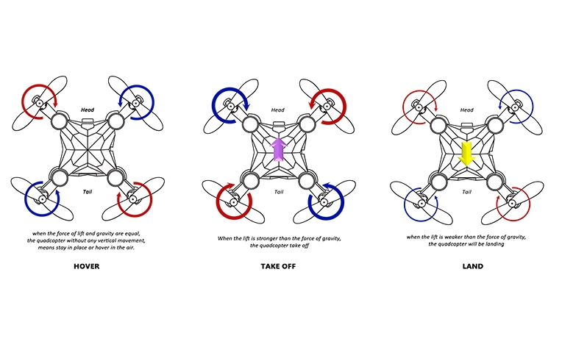
(From: https://www.holystone.com/Article/detail/id/2872.html)

Movement:
  - Forward/Backward: Increasing the speed of the rear rotors tilts the drone forward, causing it to move in that direction. The opposite happens for backward movement.
  - Left/Right: Increasing the speed of the rotors on one side (left) tilts the drone, causing it to move sideways (right).
  - Turning: Slightly increasing the speed of rotors spinning in one direction causes the drone to rotate in the opposite direction.
- Stability: The flight controller constantly adjusts the speed of each rotor to maintain balance and stability, even in windy conditions.
- Control: The drone is controlled remotely using a transmitter (remote control) or a smartphone app. The controller sends signals to the flight controller, which translates them into motor adjustments.
Additional Features
- GPS: Allows for autonomous flight, return-to-home, and waypoint navigation.
- Obstacle Avoidance: Sensors help the drone detect and avoid obstacles.
- Follow Me Mode: The drone can automatically follow a subject.

